CC 207B Unit 5 Exercise
Name:Joseph Angelo O. Japitana Date: 10/16/2026
Year and Section: BSIT 3-B
Note: Upload your Flutter project to your assigned folder here -> https://github.com/WVSU-BSIT-Batch-2028/CC-207B_26-27_Activities. Read the instructions on submitting, including the file name/folder conventions in the GitHub repository.

I. Profile Screen Development with Flutter. Develop a two-screen Flutter app about you: a Profile screen and a My Pet screen, switched with a bottom navigation bar. The Profile screen only shows information, so you will build it from stateless widgets. The Pet screen reacts to taps, so it needs a StatefulWidget and setState(). Along the way you will use the Dart features from 5.1 (classes, named parameters, lists, null safety, async/await) inside real widgets.
Before you start, make sure you have performed the following:
- Create the project: flutter create <lastname>_unit5_exercise (follow the naming convention in the submissions repository).
- Make two folders: assets/images/ (your photo and your pet's photo) and assets/sounds/ (a short .mp3 or .wav of a sound like your pet's). No pet? Use a favorite animal, and say so on the screen.
- Add the audio package: flutter pub add audioplayers.
- Declare your assets in pubspec.yaml, then save (or run flutter pub get):
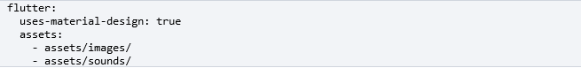
Your main.dart should follow the following structure:
- Use MaterialApp with a theme: ThemeData(colorSchemeSeed: Colors.indigo) (choose your own color). Style everything through Theme.of(context): no hard-coded font sizes or colors in your screens.
- Make a HomeShell StatefulWidget with a Scaffold and a NavigationBar that has two destinations, Profile and My Pet. Keep the selected index in your State and change it with setState().

Your application should contain the following:
  - A profile screen with components such as:
      - Header: an AppBar whose title is your name.
      - Profile row: your photo on the left, shown as a circle (Image.asset inside ClipOval, or CircleAvatar). On the right, a Column with your full name (textTheme.headlineSmall) and a one-line tagline. Wrap that Column in Expanded so a long name wraps instead of overflowing.
      - Information section: at least 5 rows. Each row has an icon that matches the information, a label, and the value (example: Hobbies, "Coding, Badminton"). Do not copy and paste five rows. Instead:
        - Write a ProfileInfo class with final fields (icon, label, value), a const constructor and required named parameters.
        - Put your rows in a List<ProfileInfo>.
        - Write your own InfoTile StatelessWidget for one row, and build the rows with a collection-for: for (final info in infos) InfoTile(info: info).
      - Biography: a Card with the title "My Biography" (textTheme.titleLarge) and one paragraph about you (textTheme.bodyMedium).
      - No overflow: the page scrolls (SingleChildScrollView) and shows no yellow-and-black overflow stripes on a small phone or a narrow desktop window.
      - Accessibility: give your photo a semanticLabel, for example "Photo of Juan Dela Cruz".
Sample designs (layout ideas from previous students):

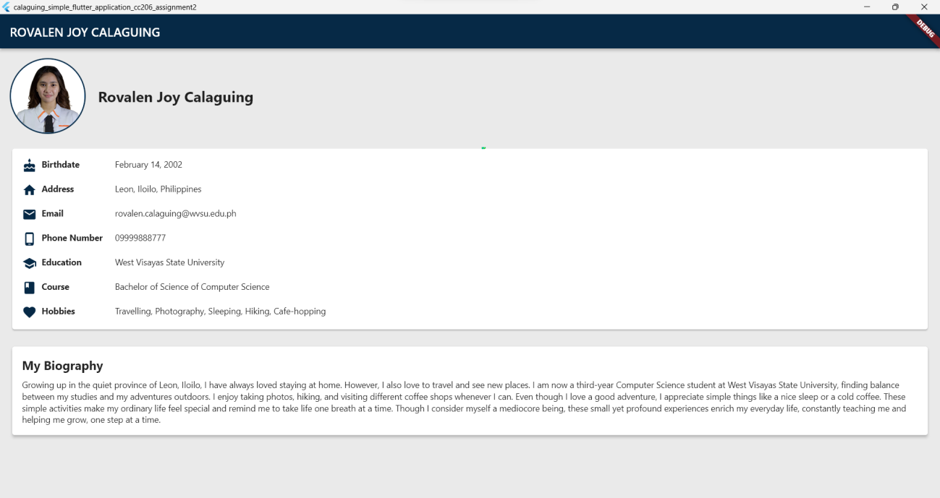

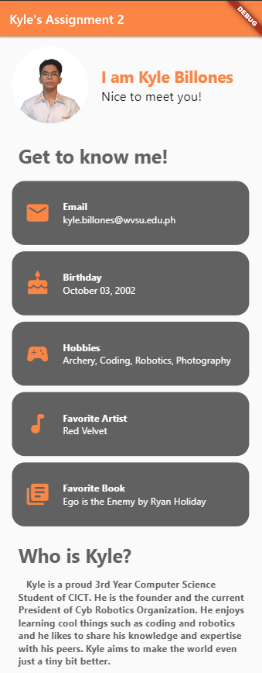
  - A Home Screen where it displays two big components: A) A picture of your pet, and B) A button that plays a sound similar to the sound made by your pet.
    - Make sure that the assets (image and audio), are embedded if local.
    - Photo: a large photo of your pet with Image.asset, BoxFit.cover and rounded corners (ClipRRect). Add a semanticLabel.
    - Sound button: a FilledButton.icon that plays your pet sound from your assets.
    - Feedback: while the sound plays, the button is disabled (onPressed: null) and its label says "Playing...". It turns back on when the sound finishes.
    - Counter: a line of text such as "Bantay has barked 3 times." that goes up on every play.
    - Gesture: double-tapping the photo toggles a heart icon on top of it (GestureDetector with onDoubleTap, and a Stack).
    - Lifecycle: create the AudioPlayer once and release it in dispose().
  - Starter code for the audio player:
import 'package:audioplayers/audioplayers.dart';

class _PetScreenState extends State<PetScreen> {
final AudioPlayer _player = AudioPlayer();
bool _isPlaying = false;
@override
void initState() {
super.initState();
_player.onPlayerComplete.listen((_) {
if (mounted) setState(() => _isPlaying = false);
});
}

@override
void dispose() {
_player.dispose(); // release what you created
super.dispose();
}

Future<void> _playSound() async {
setState(() => _isPlaying = true);
// AssetSource looks inside the assets/ folder
await _player.play(AssetSource('sounds/pet_sound.mp3'));
}
// build(): ...
}

Evidences (Screenshot that the application is working):
